ATTACHMENT D
Page 1 of 2
PRICING AND SERVICE PROPOSAL – All FirstLine Schools

Pricing Full Service APPA Level 2

• 200 Days/Year providing all services covered in Scope of Work items 1-A, 1-B, 1-C, 2 and 3 (Daily, Nightly, Weekly and Monthly services)

• 60 Days/Year providing all services covered in Scope of Work items 3, 4, 5 and 6 (Weekly, Monthly, Semi-annual and special services)

LOCATION | PRICE
Samuel J. Green
Arthur Ashe
Langston Hughes
Phillis Wheatley
FirstLine Live Oak

ATTACHMENT D
Page 2 of 2

PRICING AND SERVICE PROPOSAL – ADDITIONAL SERVICES

Throughout the course of this contract FirstLine may be in need of planned, emergency, temporary or permanent additional custodial support. Any category the Proposer does not wish to bid on must be indicated with N/A.

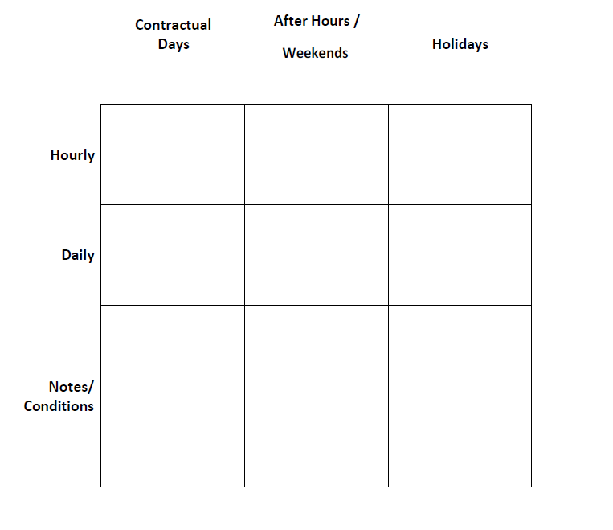

ATTACHMENT E
Page 1 of 1

CONTACT INFORMATION/BID AUTHORIZATION
FirstLine Schools
Primary Contact Name
Primary Contact Phone Number
Primary Contact Email Address
Company Legal Name
Company Address
Company Website

Company Website
Year Company Founded
Years Operating in New Orleans
Number of Clients
Number of Employees
Certified SLDBE (yes/no)
If YES, Year Certified
Samuel J. Green Charter School
Arthur Ashe Charter School
Phillis Wheatley Community School
Langston Hughes Academy
FirstLine Live Oak

By signing the box below I am submitting my bids for the following facilities (check all that apply):

Authorized Representative Name

Authorized Representative Signature

Date of RFP Bid Submittal

ATTACHMENT F

Non-Collusion
AFFIDAVIT

Non-Collusion AFFIDAVIT STATE OF _______________
PARISH/COUNTY OF _______________

BEFORE ME, the undersigned authority, personally came and appeared, _____________________________, (Affiant) who after being duly sworn, deposed and said that he/she is the fully authorized ________________________ of ___________________________ (Entity), the party who submitted a Proposal/Contract/Bid/RFP/SOQ No. __________________, to FirstLine Schools. Affiant further said:
(1) That Affiant has not and will not employ any person, either directly or indirectly, to secure the public contract under which he/she is to receive payment, other than persons regularly employed by the Affiant whose services, in connection with the project or in securing the public contract, are in the regular course of their duties for the Affiant; and
(2) That no part of the contract price was paid or will be paid to any person for soliciting the contract, other than the payment of normal compensation to persons regularly employed by the Affiant whose services with the project are in the regular course of their duties for the Affiant.

_______________________________________
Signature of Affiant

SWORN TO AND SUBSCRIBED
BEFORE ME ON THIS ________ DAY OF
________________, 20____. _______________________________

_______________________________________
NOTARY PUBLIC

ATTACHMENT G

Responsibility Disclosures
Responses to the following questions must accompany the contractor’s bid. A bid may be deemed non-responsive if the contractor fails to provide complete answers or provides false statements to any of the questions provided herein. If any change(s) occur(s) during the bidding process, updated responses must be provided within thirty (30) calendar days of such change(s).

1. Please indicate whether, within the past five (5) years, your firm has been the defendant in any type of court action(s) for (an) alleged violation(s) of labor or employment laws in connection with a contract for custodial services. __ Yes __ No

If yes, please explain the circumstances, including the specific allegation(s) filed against your firm; the name of the plaintiffs; the case number; and the disposition/current status of each case.

2. Please indicate whether, within the past five (5) years, your firm or any of its owners, partners, or officers, has/have ever been investigated, cited, assessed any penalties, or found to have violated any labor or employment laws. __ Yes __ No

If yes, please explain the circumstances, including the specific charge(s) filed against your firm, its owners, partners, and/or officers; the agency that was involved; and the disposition/current status of each case.

3. If a license is required for any of the services performed by your firm, please indicate whether, within the past five (5) years, your firm, or any individual employed by your firm, has been investigated, cited, assessed any penalties, subject to any disciplinary action by a licensing agency, or deemed to have violated any licensing laws. __ Yes __ No

If yes, please explain the circumstances, including the specific charge(s) filed against your firm; the licensing agency that was involved; and the disposition/current status of each case.

_______________________________________
Signature of Legally Responsible Party

_______________________________________
Date

ATTACHMENT H
Page 1 of 1

CHECKLIST OF REQUIRED ELEMENTS

ITEM | PAGE | INCLUDED (y/n) | INITIALS
Executive Summary
Company Overview/Fiscal Responsibilities Summary
Organization Policies and Procedures
Performance History & Preparedness for FirstLine
Customer Service Proposal
Implementation/Transition Plan
Insurance Ability or Certificates
Service Proposal – Pricing Sheet – Attachment D
Contact Information/Bid Authorization – Attachment E
Non-Collusion Affidavit – Attachment F
Responsibility Disclosures – Attachment G
Checklist (This Document) – Attachment H
Sealed Original + Hard Copy + Electronic Copy | n/a

